**PSG COLLEGE OF TECHNOLOGY, COIMBATORE – 641 004**

**Department of Applied Mathematics and Computational Sciences**

**MSc SOFTWARE SYSTEMS – Semester IV**

**20XW48 – Web Designing Lab**

**PROBLEM SHEET – JavaScript Basics & Control Statements**

**By Abishek A 20pw01**

1. Write a JavaScript in a web page to display the current day and time.

<html>

<body>

<h2 id="displayDateTime"></h2>

</body>

<script type="text/javascript">

var today = new Date();

var day = today.getDay();

var daylist = ["Sunday","Monday","Tuesday","Wednesday ","Thursday","Friday","Saturday"];

var date = today.getFullYear()+'-'+(today.getMonth()+1)+'-'+today.getDate();

var time = today.getHours() + ":" + today.getMinutes() + ":" + today.getSeconds();

var dateTime = date+' '+time;

document.getElementById("displayDateTime").innerHTML = dateTime + ' <br> Day :- ' + daylist[day];

</script>

</html>

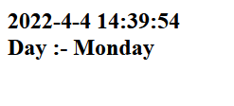

1. Write a JavaScript to convert a temperature Celsius to Fahrenheit and a temperature in Fahrenheit to Celsius.

<!DOCTYPE html>

<html lang="en">

<head>

<meta charset="UTF-8">

<meta http-equiv="X-UA-Compatible" content="IE=edge">

<meta name="viewport" content="width=device-width, initial-scale=1.0">

<title>Temperature</title>

</head>

<body>

<h2>farenheit to celcius</h2>

<h2 id="ftoc"></h2>

<h2>celcius to farenheit</h2>

<h2 id="ctof"></h2>

<script type="text/javascript">

let far = parseFloat(prompt('Enter temperature in fahrenheit: '));

let cel = Math.round((fToc(far) + Number.EPSILON) * 100) / 100;

document.getElementById("ftoc").innerHTML = cel

alert(cel);

cel = parseFloat(prompt('Enter temperature in celsius: '));

far = Math.round((cTof(cel) + Number.EPSILON) * 100) / 100;

document.getElementById("ctof").innerHTML = far

alert(far);

function fToc (far) {

let cel = (5/9) * (far-32);

return cel;

}

function cTof (cel) {

let far = (9/5)*cel + 32;

return far;

}

</script>

</body>

</html>

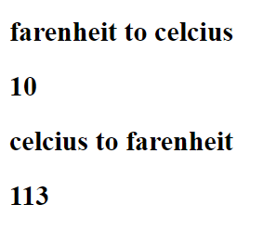

1. Write a JavaScript to compute Simple Interest and Compound Interest for a given Principal, Rate of Interest and Duration of years. Use input popup box to get the input from the user. The formula are

$Simple Interest= \frac{Principal*Years*Rate of Interest}{100}$

$Compound Interest=$*1000 $\left[{\left(1+\frac{10}{100}\right)}^{5}\right]$* - 1*

*<!DOCTYPE html>*

*<html lang="en">*

*<head>*

*<meta charset="UTF-8">*

*<meta http-equiv="X-UA-Compatible" content="IE=edge">*

*<meta name="viewport" content="width=device-width, initial-scale=1.0">*

*<title>Document</title>*

*</head>*

*<body>*

*<h2 id="si">Simple Interest: </h2>*

*<h2 id="ci">Compound Interest: </h2>*

*<script>*

*let p=parseFloat(prompt("Enter the amount: "));*

*let n=parseFloat(prompt("Enter duration in years: "));*

*let r=parseFloat(prompt("Enter rate of interest: "));*

*let si = p*n*r/100;*

*let ci = (p*Math.pow((1+(r/n)),n))-1;*

*document.getElementById("si").innerHTML=si;*

*document.getElementById("ci").innerHTML=ci;*

*</script>*

*</body>*

*</html>*

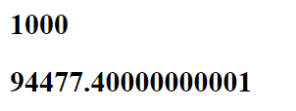

1. Write a JavaScript program that accepts two points and determines the distance between them. Use input popup box to get the input and display the calculated value using alert popup box. The formula is $Distance= \sqrt{{\left(x2-x1\right)}^{2}+{\left(y2-y1\right)}^{2}}$

<!DOCTYPE html>

<html lang="en">

<head>

<meta charset="UTF-8">

<meta http-equiv="X-UA-Compatible" content="IE=edge">

<meta name="viewport" content="width=device-width, initial-scale=1.0">

<title>Document</title>

</head>

<body>

<p>(x1,y1)=(<span id = "x1"></span>,<span id = "y1"></span>)</p>

<p>(x2,y2)=(<span id = "x2"></span>,<span id = "y2"></span>)</p>

<h2>

Distance = <span id="d"></span>

</h2>

<script>

let x1=parseInt(prompt("x1= "));

let y1=parseInt(prompt("y1= "));

let x2=parseInt(prompt("x2= "));

let y2=parseInt(prompt("y2= "));

let d = Math.sqrt(Math.pow((x2-x1),2)+Math.pow((y2-y1),2));

d=Math.round((d + Number.EPSILON) * 100) / 100;

document.getElementById("x1").innerHTML = x1;

document.getElementById("y1").innerHTML = y1;

document.getElementById("x2").innerHTML = x2;

document.getElementById("y2").innerHTML = y2;

document.getElementById("d").innerHTML = d;

</script>

</body>

</html>

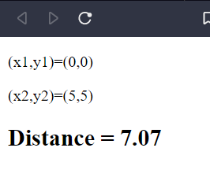

1. Write a JavaScript program to compute the Area of a Triangle when the three sides are given. The formula is $Area= \sqrt{s\left(s-a\right)\left(s-b\right)(s-c)}$, where $S= \frac{(a + b + c)}{2}$

<!DOCTYPE html>

<html lang="en">

<head>

<meta charset="UTF-8">

<meta http-equiv="X-UA-Compatible" content="IE=edge">

<meta name="viewport" content="width=device-width, initial-scale=1.0">

<title>Document</title>

</head>

<body>

<h2>

a=<span id="a"></span>,&ensp;b=<span id="b"></span>,&ensp;c=<span id="c"></span>

</h2>

<h2>

Area = <span id = "ar"></span>

</h2>

<script>

let a=parseFloat(prompt("a= "));

let b=parseFloat(prompt("b= "));

let c=parseFloat(prompt("c= "));

let s=(a+b+c)/2;

let ar = Math.sqrt(s*(s-a)*(s-b)*(s-c));

ar=Math.round((ar + Number.EPSILON) * 100) / 100;

document.getElementById("a").innerHTML = a;

document.getElementById("b").innerHTML = b;

document.getElementById("c").innerHTML = c;

document.getElementById("ar").innerHTML = ar;

</script>

</body>

</html>

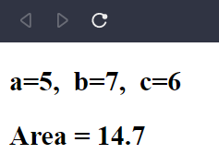

1. Write a JavaScript that asks the user to enter two numbers, obtains the two numbers from the user and outputs text that displays the sum, product, difference and quotient of the two numbers.

<!DOCTYPE html>

<html lang="en">

<head>

<meta charset="UTF-8">

<meta http-equiv="X-UA-Compatible" content="IE=edge">

<meta name="viewport" content="width=device-width, initial-scale=1.0">

<title>Document</title>

</head>

<body>

<h2>The numbers are a=<span id="a"></span>&ensp;and b=<span id="b"></span></h2>

<h3>a+b=<span id="sum"></span></h3>

<h3>a+b=<span id="diff"></span></h3>

<h3>a+b=<span id="prod"></span></h3>

<h3>a+b=<span id="quo"></span></h3>

<script>

let a = parseInt(prompt("Enter first no: "));

let b = parseInt(prompt("Enter second no: "));

let sum, diff, prod, quo;

sum=a+b;

diff=a-b;

prod=a*b;

quo=a/b;

quo=Math.round(quo,0);

document.getElementById("a").innerHTML=a;

document.getElementById("b").innerHTML=b;

document.getElementById("sum").innerHTML=sum;

document.getElementById("diff").innerHTML=diff;

document.getElementById("prod").innerHTML=prod;

document.getElementById("quo").innerHTML=quo;

</script>

</body>

</html>

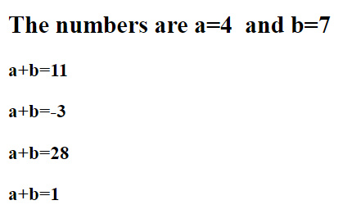

1. Write a JavaScript that takes three integers from the user and displays the sum, average, product, smallest and largest of the numbers in an alert dialog.

<!DOCTYPE html>

<html lang="en">

<head>

<meta charset="UTF-8">

<meta http-equiv="X-UA-Compatible" content="IE=edge">

<meta name="viewport" content="width=device-width, initial-scale=1.0">

<title>Document</title>

</head>

<body>

<script>

let a = parseInt(prompt("Enter first no: "));

let b = parseInt(prompt("Enter second no: "));

let c = parseInt(prompt("Enter third no: "));

let max = Math.max(a,b,c);

alert("Max among "+a+" "+b+" "+c+" is "+max);

</script>

</body>

</html>

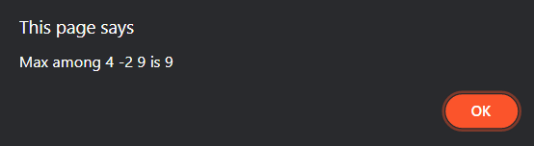

1. Write a JavaScript that inputs five numbers and determines and outputs HTML text that displays the number of negative numbers input, the number of positive numbers input and the number of zeros input.

<!DOCTYPE html>

<html lang="en">

<head>

<meta charset="UTF-8">

<meta http-equiv="X-UA-Compatible" content="IE=edge">

<meta name="viewport" content="width=device-width, initial-scale=1.0">

<title>Document</title>

</head>

<body>

<h2> a <span id="ac"></span></h2>

<h2> b <span id="bc"></span></h2>

<h2> c <span id="cc"></span></h2>

<h2> d <span id="dc"></span></h2>

<h2> e <span id="ec"></span></h2>

<script>

let a = parseInt(prompt("Enter first no: "));

let b = parseInt(prompt("Enter second no: "));

let c = parseInt(prompt("Enter third no: "));

let d = parseInt(prompt("Enter fourth no: "));

let e = parseInt(prompt("Enter fifth no: "));

document.getElementById("ac").innerHTML=check(a);

document.getElementById("bc").innerHTML=check(b);

document.getElementById("cc").innerHTML=check(c);

document.getElementById("dc").innerHTML=check(d);

document.getElementById("ec").innerHTML=check(e);

check(a);

check(b);

check(c);

check(d);

check(e);

function check (x) {

if(x===0){

return "is zero";

} else if(x>0) {

return "is positive";

} else if(x<0) {

return "is negative";

}

}

</script>

</body>

</html>

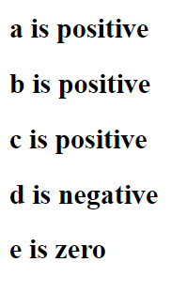

1. Write a JavaScript that reads in two integers and determines and outputs HTML text that displays whether the first is a multiple of the second.

<!DOCTYPE html>

<html lang="en">

<head>

<meta charset="UTF-8">

<meta http-equiv="X-UA-Compatible" content="IE=edge">

<meta name="viewport" content="width=device-width, initial-scale=1.0">

<title>Document</title>

</head>

<body>

<h2>First number: <span id="a"></span></h2>

<h2>Second no: <span id="b"></span></h2>

<h2 id="divisible"></h2>

<script>

let a = parseInt(prompt("Enter first no: "));

let b = parseInt(prompt("Enter second no: "));

document.getElementById("a").innerHTML=a;

document.getElementById("b").innerHTML=b;

if(b%a===0){

document.getElementById("divisible").innerHTML="The first no. is a multiple of the second no.";

} else {

document.getElementById("divisible").innerHTML="The first no. is not a multiple of the second no.";

}

</script>

</body>

</html>

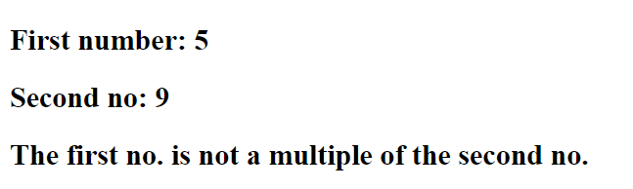

1. Write a script that calculates the squares and cubes of the numbers from 0 to 10 and outputs

HTML text that displays the resulting values in an HTML table format, as follows:

**number square cube**

0 0 0

1 1 1

2 4 8

3 9 27

4 16 64

5 25 125

6 36 216

7 49 343

8 64 512

9 81 729

10 100 1000

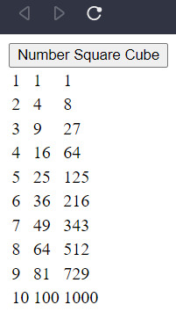

<!DOCTYPE html>

<html lang="en">

<head>

<meta charset="UTF-8">

<meta http-equiv="X-UA-Compatible" content="IE=edge">

<meta name="viewport" content="width=device-width, initial-scale=1.0">

<title>Document</title>

</head>

<body>

<input type="button" onclick=generate_table() value="Number Square Cube"></input>

<script>

function generate_table() {

let body = document.getElementsByTagName("body")[0];

let tbl = document.createElement("table");

let tblb = document.createElement("tbody");

for(let i=1; i<=10; i++) {

let row=document.createElement("tr");

for(let j=1; j<=3; j++) {

let td = document.createElement("td");

let cellText = document.createTextNode(Math.pow(i,j));

td.appendChild(cellText);

row.appendChild(td);

}

tblb.appendChild(row);

}

tbl.appendChild(tblb);

body.appendChild(tbl);

}

</script>

</body>

</html>

1. Write a JavaScript that reads a five-letter word from the user and produces all possible three letter words that can be derived from the letters of the five-letter word. For example, the three-letter words produced from the word “bathe” include the commonly used words “ate,” “bat,” “bet,” “tab,” “hat,” “the” and “tea.” Output the results in an alert popup box.

<!DOCTYPE html>

<html lang="en">

<body>

<p id="text"></p>

<script type="module">

import * as $C from 'https://cdn.jsdelivr.net/npm/js-combinatorics@1.5.6/combinatorics.min.js';

let it = new $C.Combination('bathe', 3);

document.getElementById('text').style.color = 'red';

document.getElementById('text').style.wordSpacing = '2.6rem';

for (let i = 0; i < [...it].length; i++) {

document.getElementById('text').innerHTML += `${[...it][i].join('')}<br>`

}

</script>

</body>

</html>

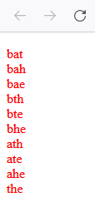

1. Write a JavaScript program to find the first occurrence and last occurrence of a string in a given string. Also find it after the specified position as well. Use string object. The web form as shown below:

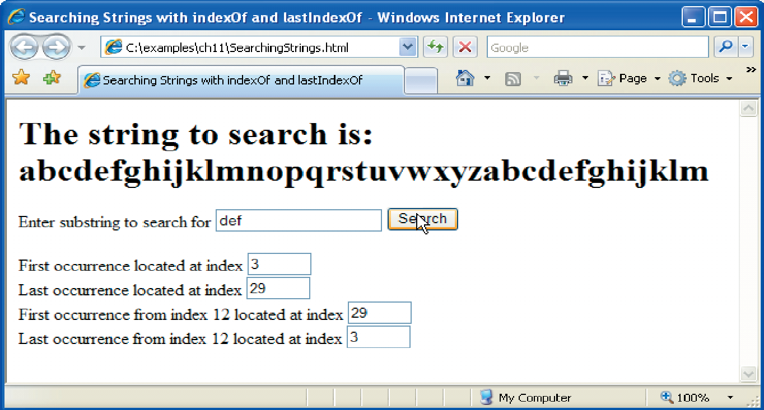

<!DOCTYPE html>

<html lang="en">

<body>

StringToSearch = <input type="text" id="input"><br>

subStr = <input type="text" id="subStr"><br>

posi = <input type="text" id="posi"><br>

<button class="go">Go</button>

<div class="result-container">

String To Search :

<h1 class="sts"></h1>

<p class="result">

</p>

</div>

<script>

goBtn = document.querySelector('.go');

goBtn.addEventListener('click', function () {

stringToSearch = document.getElementById('input').value

subStr = document.getElementById('subStr').value

posi = parseInt(document.getElementById('posi').value)

let firstOcc = stringToSearch.indexOf(subStr)

let lastOcc = stringToSearch.lastIndexOf(subStr)

let firstOccFrom = stringToSearch.indexOf(subStr, posi)

let lastOccFrom = stringToSearch.indexOf(subStr, posi)

let sts = document.querySelector('.sts')

let result = document.querySelector('.result')

sts.innerHTML = stringToSearch

result.innerHTML = `First Occurance = ${firstOcc}.<br>

Last Occurance = ${lastOcc}.<br>

First Occurance from ${posi}th index = ${firstOccFrom}.<br>

Last Occurance from ${posi}th index = ${lastOccFrom}.`

})

</script>

</body>

</html>

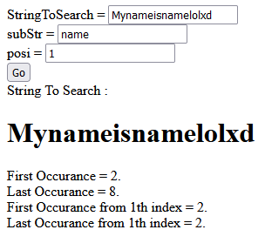

1. Dates are printed in several common formats. Write a JavaScript that reads a date from an HTML form and creates a **Date** object in which to store it. Then use the various methods of the **Date** object that convert Dates into strings to display the date in several formats.

<!DOCTYPE html>

<html lang="en">

<body>

<h3 class="date">2022-04-03</h3>

<script>

let dateEl = document.querySelector('.date')

let da = new Date(dateEl.innerHTML)

dateEl.innerHTML += da + "<br>" + da.toDateString() + "<br>" + da.toISOString() + "<br>" + da.toTimeString()

</script>

</body>

</html>

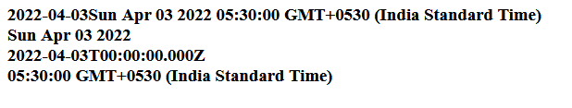

1. Write a JavaScript that tests as many of the Math library functions as you can. Exercise each of these functions by having your program display tables of return values for several argument values in an HTML textarea.

<!DOCTYPE html>

<html>

<body>

<textarea name="result" id="result" cols="30" rows="10"></textarea>

<script>

textArea = document.getElementById('result')

textArea.value = `Math library and its method showcase:\n Math.abs(-5) = ${Math.abs(-5)}\n Math.ceil(-5.5) = ${Math.ceil(-5.5)}\n Math.floor(-5.5) = ${Math.floor(-5.5)}\n Math.pow(2,2) = ${Math.pow(2, 2)}\n Math.sqrt(4) = ${Math.sqrt(4)}\n Math.round(5.5) = ${Math.round(5.5)}\n Math.random() = ${Math.random()}`

</script>

</body>

</html>

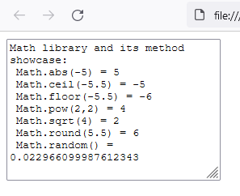

1. The process of finding the largest value (i.e., the maximum of a group of values) is used frequently in computer applications. For example, a program that determines the winner of a sales contest would input the number of units sold by each salesperson. The salesperson who sells the most units wins the contest. Write a JavaScript program that inputs a series of 10 real numbers as strings, determines the largest of the numbers and outputs a message that displays the largest number.

<!DOCTYPE html>

<html>

<body>

<script>

one = prompt("Enter first value", "1")

two = prompt("Enter second value", "2")

three = prompt("Enter third value", "3")

four = prompt("Enter fourth value", "4")

five = prompt("Enter fifth value", "5")

six = prompt("Enter sixth value", "6")

seven = prompt("Enter seventh value", "7")

eight = prompt("Enter eighth value", "8")

nine = prompt("Enter ninth value", "9")

ten = prompt("Enter tenth value", "10")

alert(`The largest of the entered values is ${Math.max(one, two, three, four, five, six, seven, eight, nine, ten)}.`)

</script>

</body>

</html>

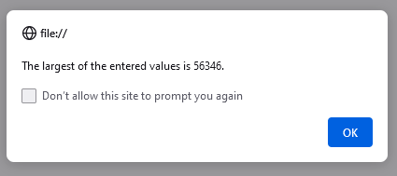

1. A mail-order house sells five different products whose retail prices are as follows: product 1, $2.98; product 2, $4.50; product 3, $9.98; product 4, $4.49; and product 5, $6.87. Write a JavaScript that reads a series of pairs of numbers as follows:

1. Product number

2. Quantity sold for one day

Your program should use a switch statement to determine each product's retail price and should calculate and output HTML that displays the total retail value of all the products sold last week. Use a ***prompt*** dialog to obtain the product number and quantity from the user. Use a sentinel-controlled loop to determine when the program should stop looping and display the final results. If the user inputs an invalid product number a proper ***alert*** window shall be displayed.

<!DOCTYPE html>

<html>

<body>

<h1 class="result"></h1>

<script>

let prices = [2.98, 4.50, 9.98, 4.49, 6.87]

let soldItems = [0, 0, 0, 0, 0]

let sentinel = 0

while (sentinel >= 0) {

let pno = prompt("Enter the product number: ", "")

sentinel = pno

if (sentinel < 0) {

alert("Input for ending the input entered. Showing results now...")

break

}

else if (sentinel > 5) {

alert("You've entered a wrong product number.")

break

}

let qno = parseInt(prompt("Enter the quantity for the day: ", ""))

soldItems[pno - 1] += qno

}

console.log(soldItems)

let totalPrice = 0

for (let i = 0; i < soldItems.length; i++) {

console.log(`Inside ${totalPrice}`)

totalPrice += soldItems[i] * prices[i]

}

document.querySelector('.result').innerHTML = `The total retail value of this week is \$${totalPrice}.`

</script>

</body>

</html>

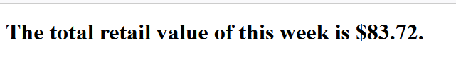

1. Develop a JavaScript program that will determine the gross pay for each of three employees.

The company pays “straight time” for the first 40 hours worked by each employee and pays “time and a half” for all hours worked in excess of 40 hours. You are given a list of the employees of the company, the number of hours each employee worked last week and the hourly rate of each employee. Your program should input this information for each employee, determine the employee’s gross pay and output HTML text that displays the employee's gross pay. Use ***prompt*** dialogs to input the data.

<html>

<body>

<h1 class="result"></h1>

<script>

empRate = [20, 40, 10]

empHours = [40, 60, 30]

let payEarned = 0

for (let i = 0; i < empRate.length; i++) {

let tempHours = empHours[i]

if (tempHours <= 40) {

payEarned += tempHours * empRate[i]

}

else {

payEarned += 40 * empRate[i]

payEarned += (tempHours - 40) * empRate[i] / 2

}

document.querySelector('.result').innerHTML += `Total pay for Employee${i + 1} = ${payEarned}.<br>`

payEarned = 0

}

</script>

</body>

</html>

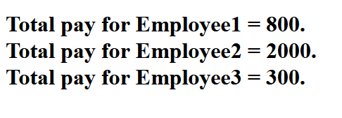

1. A company wants to transmit data over the telephone, but it is concerned that its phones may be tapped. All of its data is transmitted as four-digit integers. It has asked you to write a program that will encrypt its data so that the data may be transmitted more securely. Your script should read a four-digit integer entered by the user in a ***prompt*** dialog and encrypt it as follows: Replace each digit by (the sum of that digit plus 7) modulus 10. Then swap the first digit with the third, and swap the second digit with the fourth. Then output HTML text that displays the encrypted integer.

<html>

<body>

<h1 class="result">

Encrypted integer:

</h1>

<script>

let int = prompt("Enter an four-digit integer: ");

let digits = int.toString(10).split('').map(Number);

for (let i = 0; i < digits.length; i++) {

digits[i] = (digits[i] + 7) % 10;

}

let temp = digits[0];

digits[0] = digits[2];

digits[2] = temp;

temp = digits[1];

digits[1] = digits[3];

digits[3] = temp;

document.querySelector('.result').innerHTML += `${digits.join('')}.<br>`

</script>

</body>

</html>

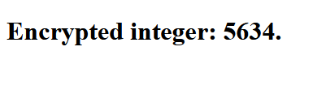

1. Write a script that finds the smallest of several non-negative integers. Assume that the first value read specifies the number of values to be input from the user. Write a script that finds the smallest of several non-negative integers. Assume that the first value read specifies the number of values to be input from the user.

<!DOCTYPE html>

<html>

<body>

<h1 class="result">

</h1>

<script>

let noOfVal = prompt("Enter the number of values you're going to enter: ", "")

listOfVal = []

for (let i = 0; i < noOfVal; i++) {

listOfVal.push(parseInt(prompt("Enter the value", "")))

}

let minVal = 999999

for (let i = 0; i < listOfVal.length; i++) {

if (listOfVal[i] < minVal) {

minVal = listOfVal[i]

}

}

document.querySelector('.result').innerHTML = `The min of the entered values are ${minVal}.`

</script>

</body>

</html>

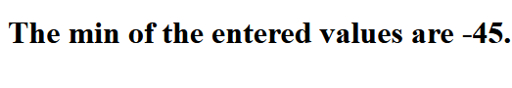

1. A palindrome is a number or a text phrase that reads the same backward and forward. For example, each of the following five-digit integers is a palindrome: 12321, 55555, 45554 and 11611. Write a script that reads in a five-digit integer and determines whether it is a palindrome. If the number is not five digits long, display an ***alert*** dialog indicating the problem to the user. Allow the user to enter a new value after dismissing the ***alert*** dialog.

<html>

<body>

<h1><span id="no"></span><span id="c"></span></h1>

<script>

function checkPalindrome (n) {

let inverted = n.split("").reverse().join("");

if(inverted==n)

document.getElementById("c").innerHTML = " "+"is a palindrome";

else

document.getElementById("c").innerHTML = " "+"is not a palindrome";

}

let n = prompt("Enter a 5 digit number: ");

while(n<10000 || n>99999){

alert("Enter valid 5 digit number!");

n = parseInt(prompt("Enter a 5 digit number: "));

}

document.getElementById("no").innerHTML = n;

checkPalindrome(n);

</script>

</body>

</html>

